Lab5 Post Lab
Team Number: 48
Team Members: Shihong Yuan(syuan19),Liangbing Zhao (lz36), Daniel Koltchev (dvk2),Sebastian Misong (missong2)
1. Design Description
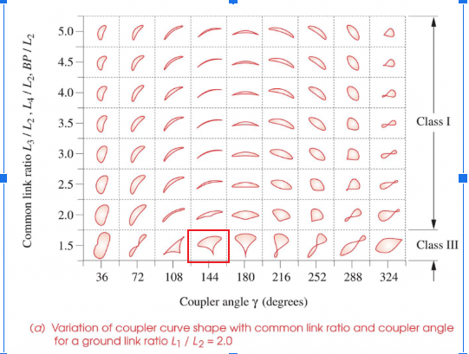
Our team was assigned the "Umbrella" coupler curve from the Hrones & Nelson atlas, with specified design parameters of a=1.5 and a coupler angle of 144∘. Based on our graphical synthesis, the calculated link lengths for our four-bar linkage are:
- Ground link (L1​)=2*L2 4.0 units
- Crank (L2​): 2 units
- Coupler (L3​)=1.5*L2: 3 units
- Follower (L4​)1.5*L2: 3 units
- BP=1.5*L2: 3 units
To determine the Grashof class, we apply Grashof's criterion (S+L≤P+Q), where S is the shortest link, L is the longest link, and P and Q are the other two links.
- S=L2​=2
- L=L1​=4.0
- P,Q=L3​,L4​=3.0,3.0
The calculation gives S+L=2.0+4.0=6.0, and P+Q=3.0+3.0=6.0. Because S+L=P+Q, this is a special case Grashof linkage (also called a Class I linkage on the boundary). Since the shortest link is the crank, it functions as a crank-rocker mechanism. This specific type of linkage is capable of generating special curve features, and with the coupler point (P) defined at a distance of 3.0 units from the coupler-follower joint (B), the resulting coupler curve contains a cusp.
However, the special condition S+L=P+Q introduces a significant practical challenge. At least once during its cycle of motion, all four links of the mechanism will become collinear (lined up in a straight line). This configuration is known as a toggle position or dead point. At this precise moment, the output motion can become indeterminate, and the internal forces and joint torques can become theoretically infinite, which could cause the mechanism to lock up or break under load.

2. Figures
Figure 1: Assigned Motion. The target coupler curve, "Umbrella," for a=1.5 and a coupler angle of 144 degrees, as found in the Hrones and Nelson atlas.
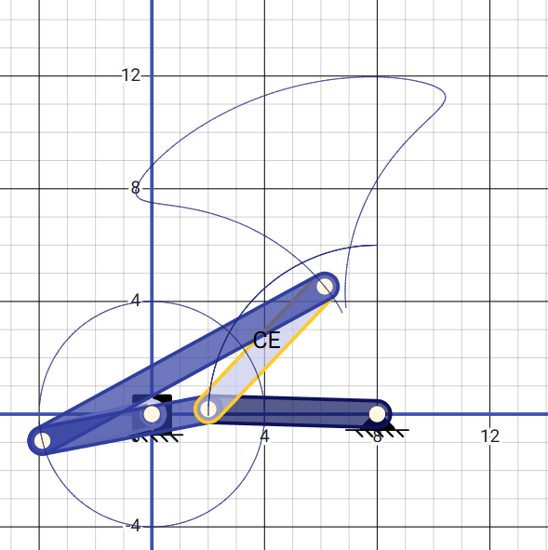
https://app.pmksplus.com/?0P.TY.K,5Y.101.MA,A,0,0,0.GB,B,0x6,KL,0.GC,C,XT,ZG,0.KD,D,1z0,0,0.GE,E,1Zm,1bZ,0..YRAB,AB,Fe,Fe,0TZ,AB,c5cae9,A,B,,.YRBC,BC,Fe,Fe,0Cr,Rp,303e9f,B,C,,.YRCD,CD,Fe,Fe,1FF,He,0d125a,C,D,,.YRCE,CE,Fe,Fe,12c,14Q,c5cae9,C,E,,.YRBE,BE,Fe,Fe,KL,yy,303e9f,B,E,,...N_8

Figure 2: Fabricated Physical Prototype. A photograph of the physical four-bar linkage constructed for this lab.
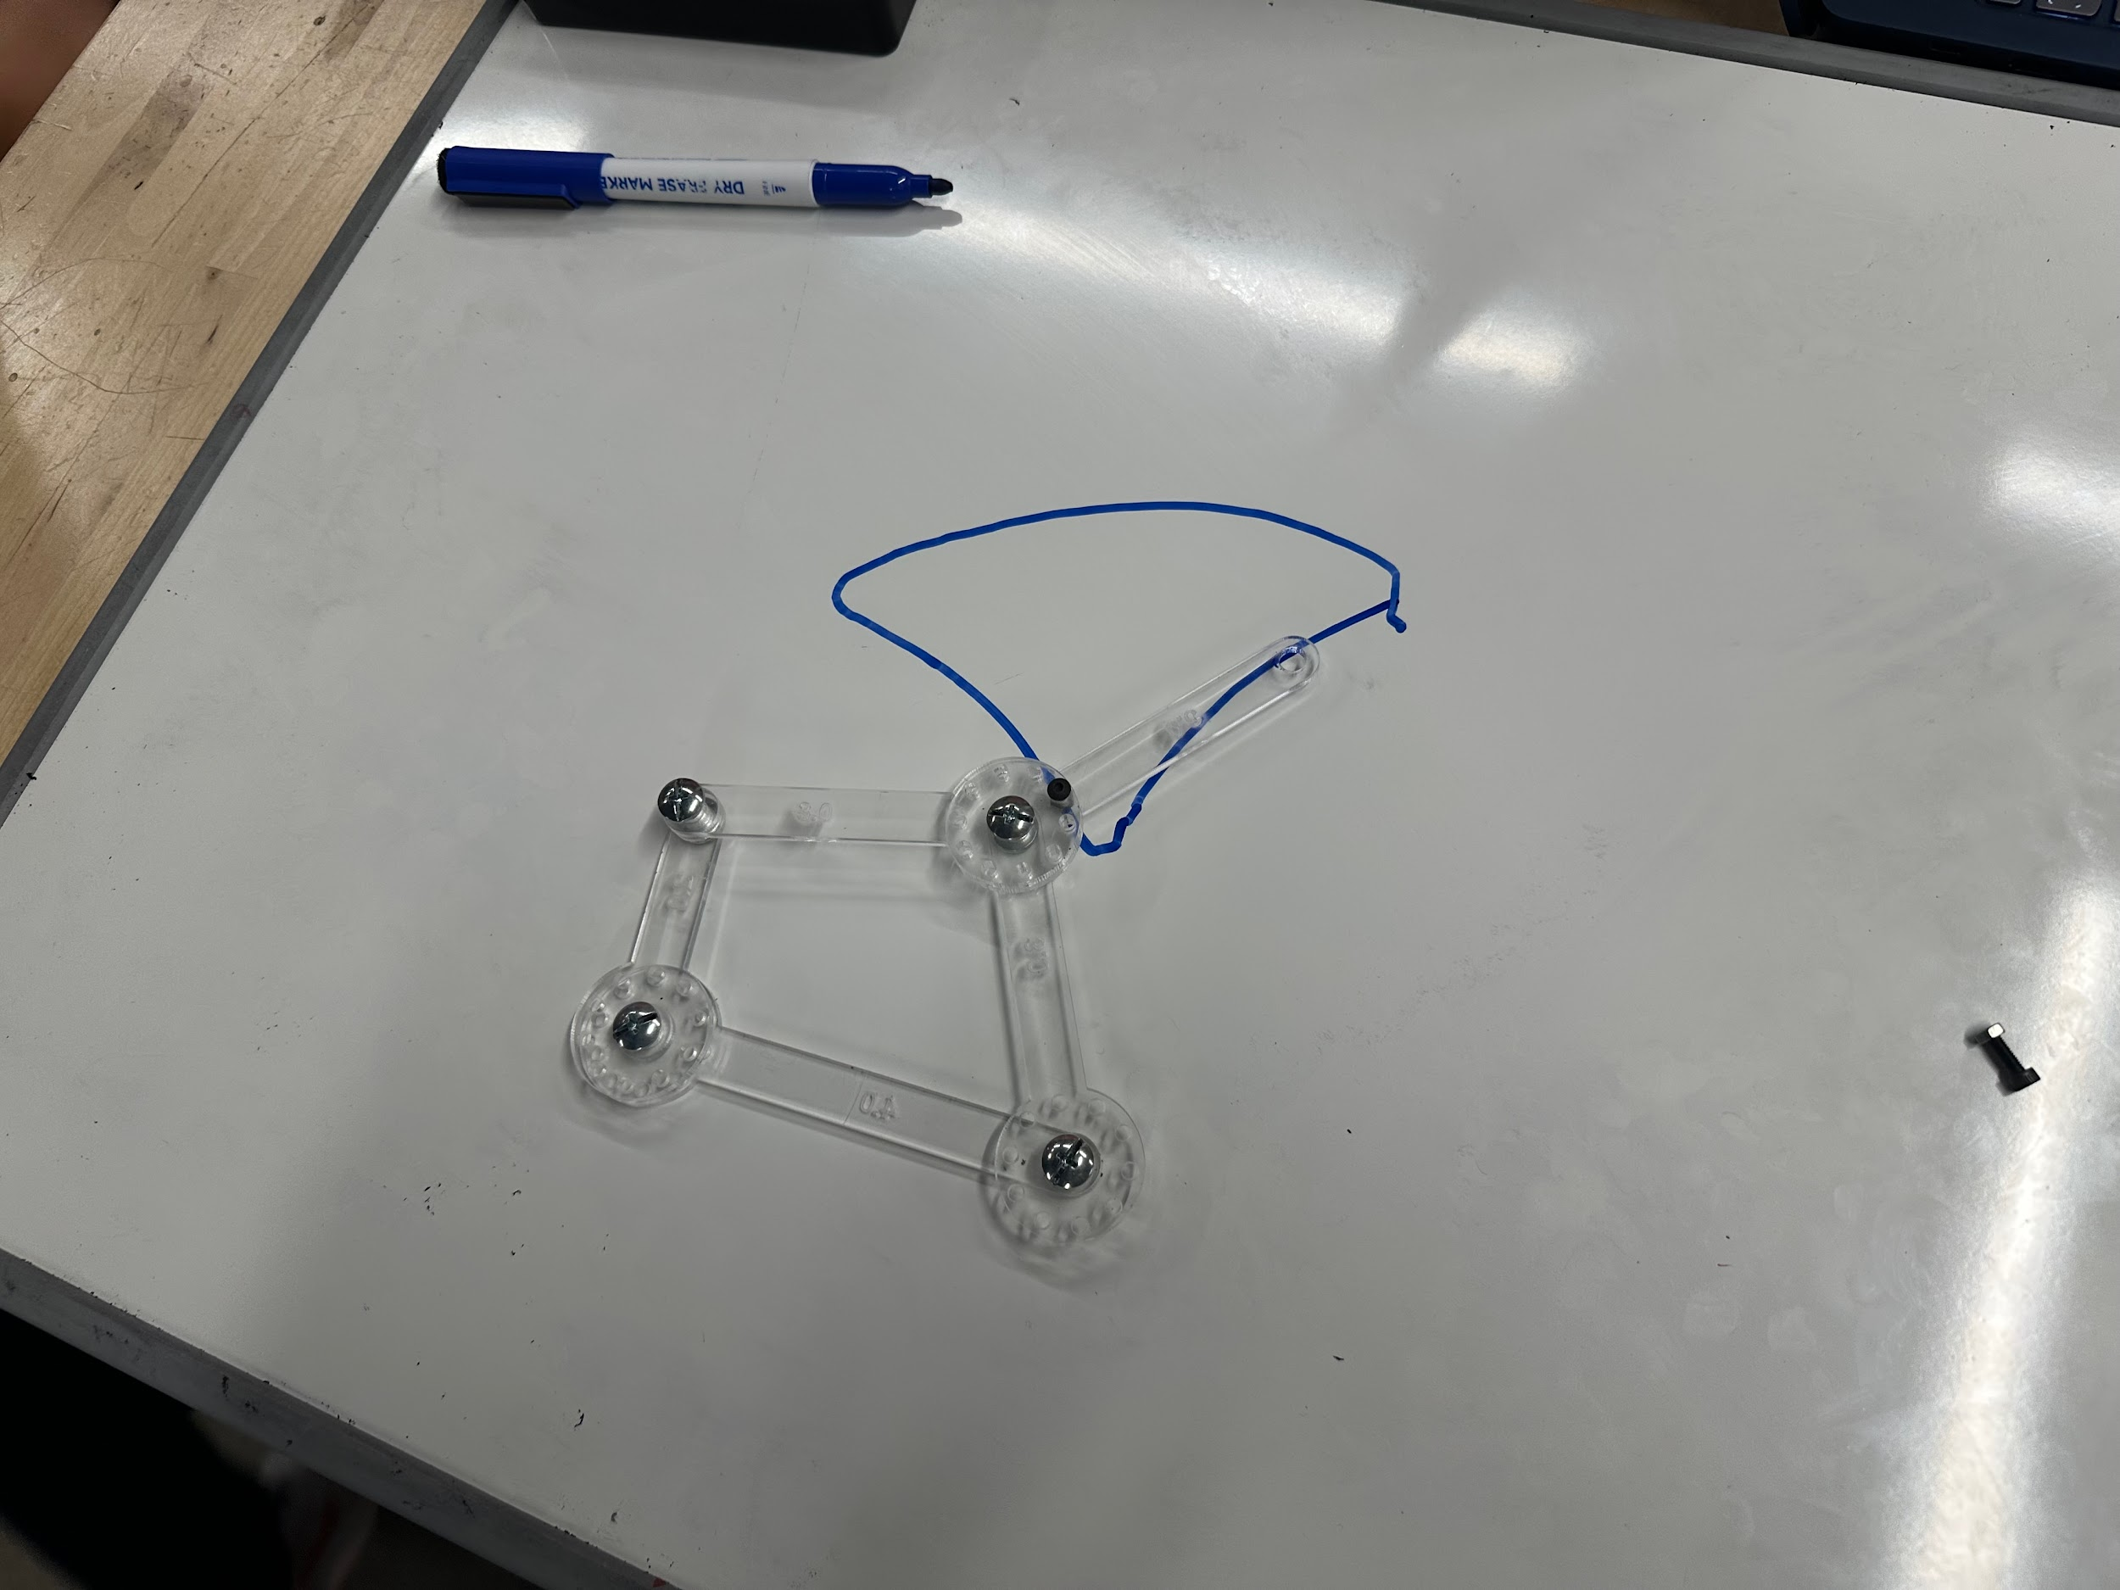
Figure 3: Comparison of Simulated Mechanism and Tracked Physical Path. The path traced by the physical prototype (red, dashed line), obtained via Tracker, is overlaid onto the path generated by the simulated mechanism (blue, solid line).
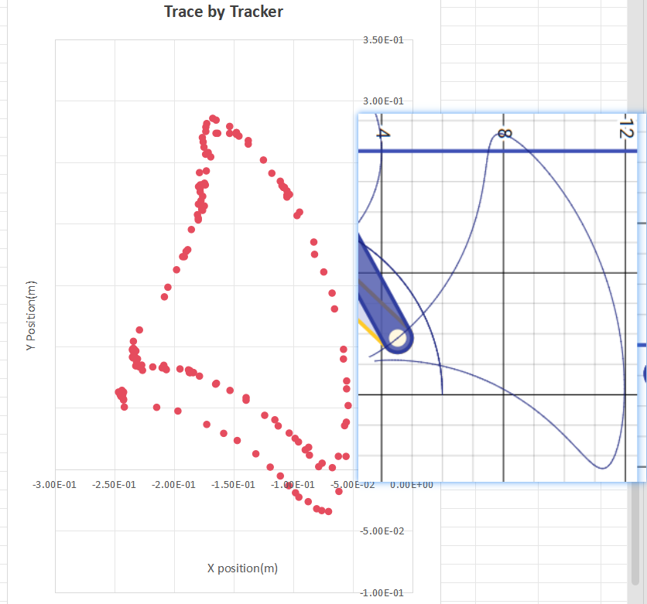
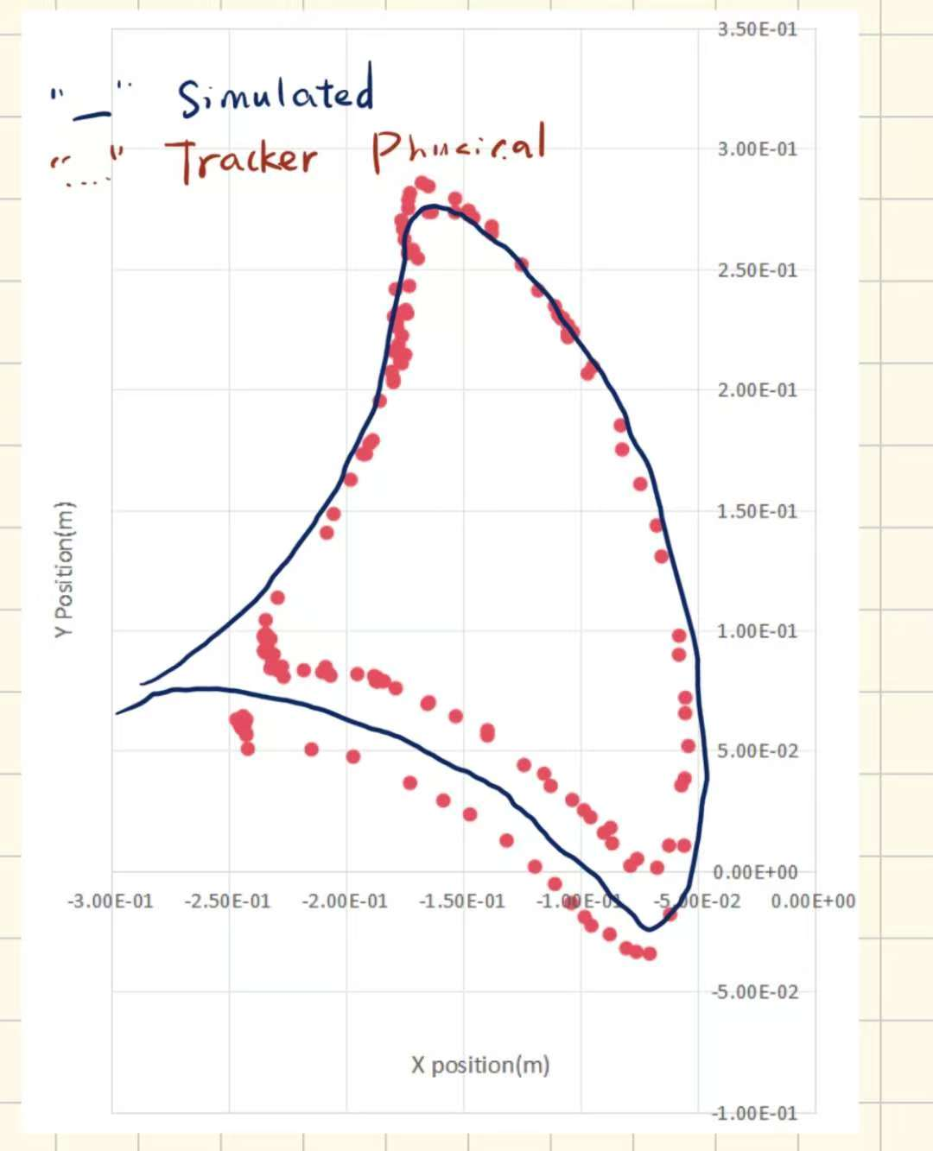

Figure 4: Position Plot from Tracker Software. An X-Y plot showing the position of the coupler point on the physical prototype as captured by Tracker. The axes are scaled to real-world units (meters).
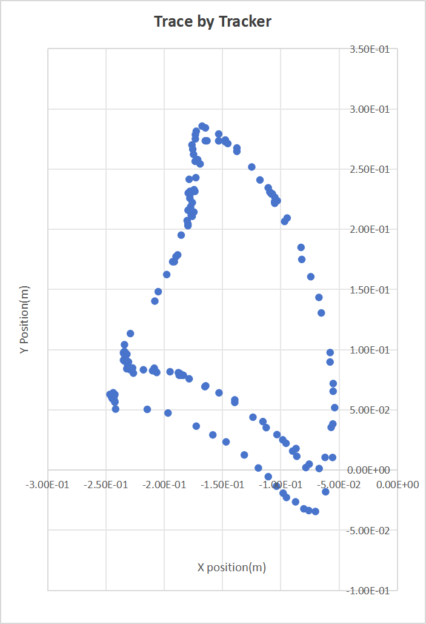

3. Design Challenges
Our team encountered two main challenges during the completion of this lab: one related to the physical fabrication of the mechanism, and the other to the final data analysis and visualization. The first challenge emerged during the assembly of our prototype. We initially found that the mechanism's movement was not smooth and would frequently jam or get stuck during rotation. We determined that this was caused by friction between the overlapping links and the base surface. To solve this, we reassembled the joints using small washers as spacers, which provided the necessary clearance to separate the links and allow them to move freely without rubbing. The second challenge was methodological, as we were initially unsure how to accurately overlay the two curves for Figure 3. The primary difficulty was combining the curve from our simulation with the one from the Tracker software while ensuring both were on the exact same scale and correctly aligned. After some investigation, we learned that the most reliable method was not to overlay images, but to export the raw coordinate data from both systems and plot them together on a single graph, which solved the problem of scaling and alignment.

4. Comparison and Error Analysis
A detailed comparison between the simulated and physical curves reveals the following key differences:
- Overall Shape vs. Precision: While the physical prototype successfully replicates the general "Umbrella" shape predicted by the simulation, the traced path shows noticeable deviations and data scatter. It lacks the perfect smoothness of the theoretical model.
- Cusp Definition: A primary distinction lies in the fidelity of the curve's features. The simulation shows a distinct and sharp cusp, which is a key characteristic of the theoretical motion. In contrast, this point is significantly less defined and appears rounded on the path traced by the physical prototype.
- Positional Accuracy: The experimental data points consistently fall both inside and outside the ideal simulated line, indicating a degree of positional error and a lack of perfect repeatability in the physical mechanism's movement.

Several sources of error likely contribute to these differences. A primary source was mechanical instability; we observed that the joints, which were fastened with screws, had a small amount of clearance. This "slop" allowed for undesirable wobble during motion, which directly accounts for much of the scatter seen in the tracked data. Another potential issue was the experimental setup itself; although we attempted to fix the mechanism's base and keep the camera stationary, any slight movement of the linkage or the camera between the two captured rotations could cause the paths to misalign.

To minimize these errors, we took several precautions during the experiment, such as firmly securing the linkage base and running the mechanism for two full cycles to observe a consistent overall trajectory. However, for future improvement, more could be done. Fabricating the links using a more precise method like 3D printing would ensure their dimensional accuracy. The mechanical consistency could be greatly improved by using shoulder bolts or bearings for the joints to eliminate slop and reduce friction. Finally, mounting the camera on a rigid tripod and using controlled, even lighting would enhance the accuracy of the Tracker software by preventing parallax error and ensuring the marker is consistently captured.

